BLOCKCHAIN IN AGRICULTURE

PURUSHOTHAMAN.P  
 Department of Information Technology  
 Sri Sivasubramaniya Nadar College of Engineering  
 Tamil Nadupurushotaman2110796@ssn.edu.in

KARUNAGARAN.R  
 Department of Information Technology  
 Sri Sivasubramaniya Nadar College of Engineering  
 Tamil Nadukaruna2110596@ssn.edu.in

Dr.N.SRIPRIYA  
Department of Information

Technology  
 Sri Sivasubramaniya Nadar College of Engineering  
Tamil Nadu  
sripriyan@ssn.edu.in

**Abstract—** This project proposes the development of a custom blockchain-based solution for the agricultural supply chain, aiming to address inefficiencies and enhance transparency. The system focuses on eliminating middlemen by directly connecting farmers, consumers, retailers, and validators in a decentralized platform. A novel **Proof of Quality (PoQ)** consensus mechanism will be employed to incentivize farmers to produce high-quality crops, with tokens rewarded based on predefined quality metrics.The platform will automate transactions, ensuring transparency and fairness in pricing. The proposed solution not only enhances traceability of products from farm to consumer but also promotes sustainable farming practices while reducing costs for consumers and improving profits for farmers. Proof of Quality (PoQ) consensus mechanism, which incentivizes farmers to produce high-quality crops by rewarding them with tokens based on predefined quality metrics.

**Keywords—** Blockchain, Agricultural Supply Chain, Proof of Quality (PoQ), IoT Integration, Decentralized Marketplace, Crop Quality Assessment, Traceability

**I.Introduction**

A. Overview

The integration of blockchain technology into the agricultural sector has the potential to revolutionize the way we perceive and participate in farming and food supply chains. Through blockchain, we can create a transparent and trustworthy platform that encapsulates the entire lifecycle of agricultural events, offering farmers a powerful tool to improve their practices and interactions. The agricultural supply chain plays a vital role in ensuring global food security and economic stability, yet it remains highly inefficient and opaque, particularly in developing regions. Farmers often face challenges such as unfair pricing, supply chain manipulation, and limited market access, which significantly impact their livelihoods. Traditional agricultural trade heavily depends on intermediaries, leading to increased costs for consumers and reduced profits for farmers. Furthermore, the lack of transparency in supply chain management makes it difficult to trace the origin and quality of agricultural products, resulting in food fraud, mislabeling, and consumer distrust. Blockchain technology has emerged as a transformative solution to address these inefficiencies by establishing a decentralized, immutable, and transparent framework for agricultural trade. By leveraging blockchain, this project aims to enhance traceability, automate transactions through smart contracts, and create a trusted environment for farmers, consumers, and retailers. The proposed system integrates a Proof of Quality (PoQ) consensus mechanism along with IoT-based quality monitoring, ensuring secure transactions and high-quality produce verification throughout the supply chain.

B.Motivation

Agriculture remains the backbone of many economies, yet smallholder farmers often struggle due to market inefficiencies, price exploitation, and the inability to access broader markets. The current system disproportionately favors middlemen, who control pricing and distribution, thereby limiting farmers' profits while increasing food costs for consumers. Additionally, existing agricultural tracking methods are manual, slow, and prone to errors, making it difficult to verify product quality, sustainability practices, and authenticity. Blockchain technology offers a novel approach to resolving these challenges by introducing trustless and tamper-proof transactions, where every stakeholder in the supply chain has equal access to verified and immutable records. With the integration of IoT sensors, real-time monitoring of crop conditions becomes feasible, ensuring that farmers are rewarded based on objective quality assessments rather than speculative pricing. The PoQ consensus mechanism further incentivizes high-quality agricultural production, as farmers receive token-based rewards for maintaining optimal product quality. The motivation for this research is driven by the growing global need to modernize agricultural supply chains and empower farmers through decentralized financial and market access. By adopting blockchain, this project aims to bridge the gap between farmers and consumers, ensure fair trade, and promote sustainability in agricultural practices.

C.Problem Definition

Despite advancements in agriculture and supply chain management, several critical challenges persist within the industry. The lack of transparency and trust remains a major concern, as consumers have limited means to verify the quality and origin of agricultural products, while farmers often have little insight into how their produce is priced and distributed, making them vulnerable to exploitative market practices. Additionally, the presence of intermediaries leads to higher food prices for consumers and lower profits for farmers, creating an unsustainable economic model. The absence of real-time quality verification further complicates matters, as traditional manual inspections for food quality are time-consuming, subjective, and prone to inaccuracies, making it difficult to ensure consistent product quality. Furthermore, smallholder farmers often struggle to receive fair compensation due to market manipulation, lack of pricing transparency, and inaccessibility to financial resources. Fraudulent practices such as mislabeling organic products, adulteration, and counterfeit goods are common, resulting in consumer distrust and potential health hazards. The lack of an effective and transparent quality verification mechanism makes it difficult to differentiate between high and low-quality produce, ultimately reducing incentives for farmers to improve their production standards. These challenges necessitate a robust, decentralized, and automated system that eliminates market inefficiencies, enhances product traceability, and ensures fair trade practices through an efficient blockchain-based solution.

D. Proposed Solution

To address the existing inefficiencies in the agricultural supply chain, this research proposes a blockchain-integrated framework that leverages smart contracts, IoT-based quality monitoring, and a Proof of Quality (PoQ) consensus mechanism to enhance fair pricing, quality verification, and transaction security. The proposed system eliminates the need for intermediaries by allowing direct farmer-to-consumer transactions, ensuring fair and transparent pricing mechanisms. The PoQ consensus mechanism rewards farmers based on real-time quality assessments, where IoT sensors collect data on temperature, humidity, soil conditions, and freshness, ensuring verifiable proof of quality is stored on the blockchain. Smart contracts automate payment settlements, enforce agreements, and validate transactions, making the process fraud-proof and highly efficient. By maintaining a transparent and immutable ledger, the proposed system enhances traceability across the entire agricultural supply chain, allowing all stakeholders to access secure and verifiable records of transactions. Additionally, the decentralized nature of blockchain technology ensures equal market access for all participants, reducing economic disparities and promoting financial inclusivity among smallholder farmers. The integration of smart contracts and decentralized finance (DeFi) solutions further enables farmers to access micro-loans and financial resources without the need for traditional banking institutions. The proposed framework not only optimizes agricultural supply chain management but also lays the foundation for a sustainable, fair, and technologically driven agricultural ecosystem.

**II. Related Works**

The comprehensive literature survey begins by reviewing studies on blockchain-based supply chain management, with particular attention to applications in agriculture.In[1], **Agriledger**, a blockchain-based solution, seeks to eliminate inefficiencies caused by intermediaries in agricultural transactions by providing transparent records and direct interactions between farmers and consumers. In this paper titled "Agriculture Supply Chain Management Based on Blockchain Architecture and Smart Contracts" [1] introduces a blockchain framework that employs smart contracts to automate supply chain transactions, ensuring data integrity and security through a decentralized ledger. The blockchain's immutable nature ensures that agricultural data, such as environmental conditions gathered via IoT sensors, is securely stored, promoting transparency and traceability within the food supply chain.

In [2], Kim and Laskowski explore the application of blockchain technology in agriculture, focusing on sustainable solutions for food supplychain, financing, and local economies. They introduce blockchain-based systems that enhance transparency in food supply chains, allowing for real-time provenance tracking from farm to fork. Additionally, the research discusses smart contracts to automate transactions and mitigate corruption, particularly benefiting small farmers in developing regions. The study also highlights the role of blockchain in supporting sustainable agricultural practices, helping local cooperatives retain more value and improve market access. Overall, the blockchain framework is positioned as a transformative tool for modernizing agricultural supply chains.

In[3]highlights the limited digitalization in agriculture, which restricts the transfer and analysis of data between farms and other entities. The paper emphasizes that agriculture lags behind in adopting digital technologies, which could help improve data-driven decision-making and transparency. Blockchain technology is proposed as a solution to increase trust, ensure traceability, and enhance the quality and safety of agricultural commodities by providing a decentralized system to handle data. It can streamline the supply chain by reducing ambiguity and ensuring compliance with standards across the entire process, from production to market. The study explores the potential of blockchain to overcome these challenges, providing benefits such as improved accountability, efficiency, and security in agricultural supplychain management.

In[4], It Explores the use of technology, specifically text messaging, as a means to enhance meal planning and dietary intake in response to the increasing prevalence of obesity in the United States. The study focuses on the effectiveness of sending weekly nudges via a Facebook group to encourage individuals to plan and prepare meals at home rather than opting for fast food. The findings suggest that sending weekly nudges with specific dietary goals significantly impacts meal planning, leading to improved dietary intake. The results have implications not only for promoting healthier lifestyles but also for addressing motivation and needs in situations such as weight loss. Key terms include text messaging, nudges, meal planning, and dietary intake.

In [5],blockchain is presented as a transformative tool for agriculture, offering transparency and trust across the supply chain. The study emphasizes that blockchain can reduce transaction costs by eliminating intermediaries and ensuring secure peer-to-peer interactions between farmers and consumers. Moreover, smart contracts enable automated, timely payments based on real-time data from IoT devices, improving both efficiency and traceability. This decentralized approach also aids in addressing issues related to food quality, safety, and agricultural insurance by providing a reliable way to record and verify transactions. However, the integration of smallholder farmers into such ecosystems remains a challenge due to the need for technological infrastructure and access.

In [6],blockchain technology is explored as a promising solution for addressing traceability issues in agricultural supply chains. The study highlights the technology's key properties, such as **reliability**, **transparency**, and **immutability**, which make it effective for tracking the origins of food products. The growing need for such traceability systems stems from widespread concerns over harmful agricultural practices, like the excessive use of pesticides and fertilizers. Moreover, consumer demand for higher-quality products has driven interest in blockchain applications in agriculture. However, the research indicates that while blockchain shows great potential, its adoption is still in the early stages, with only a limited number of real-world implementations. Countries such as China, the United States, and Italy are leading in blockchain research for agriculture, but further efforts are needed to fully realize its benefits in the sector.

In[7], The exploration of blockchain technology within agri-food supply chains has gained significant attention in recent years, particularly regarding its potential to enhance trust, safety, and quality. Various studies have highlighted the effectiveness of blockchain in improving traceability, thereby addressing critical issues such as food safety and fraud in high-value products like wine and olive oil. For instance, recent research indicates that blockchain can facilitate transparent record-keeping, allowing stakeholders to verify the authenticity and origin of products, which is essential in combating fraudulent practices. Additionally, literature reviews have pointed out the fragmented nature of existing research, suggesting a need for a cohesive understanding of blockchain's implementation across different regions and products. Notably, while the wine sector has seen substantial advancements in adopting blockchain solutions, the olive oil industry remains underexplored, indicating a gap in the literature. This body of work underscores the importance of integrating environmental and social considerations into the development of blockchain technologies, aiming not only to improve operational efficiency but also to promote sustainability and reduce waste in the agri-food supply chain.

These related works explore the potential of blockchain across various sectors, with a specific focus on agriculture. Blockchain technology offers transparency, traceability, and security through decentralized peer-to-peer networks, addressing issues such as **double-spending** (Bitcoin, Nakamoto) and improving **supply chain traceability** in agriculture (Hang Xiong, Sandeep Kumar). Blockchain helps track the provenance of agricultural products, ensuring data integrity and promoting **smart farming** via IoT integration. Furthermore, smart contracts enable automated transactions and secure payments between farmers and consumers. However, the research notes that blockchain applications are still in their early stages, requiring further adoption to fully realize their benefits

**III. Methodology**

**A. Development of a Custom Blockchain for Agricultural SupplyChain:**  
To establish a secure, transparent, and decentralized agricultural supply chain, a custom blockchain will be developed. Unlike traditional supply chain systems, which rely on centralized authorities, the proposed blockchain framework will enable direct interactions between farmers, consumers, retailers, and validators, ensuring immutable record-keeping and decentralized traceability. Every transaction, including produce submissions, quality verifications, and purchases, will be recorded on-chain, eliminating the risks of fraud, price manipulation, and data tampering. The blockchain will also store essential product metadata, such as origin, quality metrics, validation status, and transaction history, ensuring full transparency from farm to consumer.

**B. Proof of Quality (PoQ) Consensus Mechanism:** A novel Proof of Quality (PoQ) consensus mechanism will be implemented to incentivize high-quality crop production. Unlike traditional blockchain consensus algorithms, which rely on mining or staking, PoQ rewards farmers based on objective quality metrics such as freshness, organic certification, and pesticide-free status. These quality parameters will be validated through IoT sensor data and human inspection, ensuring only verified high-quality produce enters the supply chain. Farmers producing superior-quality goods will receive greater market trust and better financial incentives, thereby promoting sustainable agricultural practices.

**C. Direct Farmer-to-Consumer Transactions:** One of the primary objectives of the proposed system is to eliminate intermediaries, allowing farmers to interact directly with consumers via a blockchain-enabled marketplace. Traditional agricultural supply chains involve multiple middlemen, leading to reduced profits for farmers and inflated prices for consumers. In the proposed model, smart contracts will automate trade agreements, ensuring fair pricing and secure transactions without third-party intervention. The blockchain will record all interactions, including pricing agreements, produce quality, and payment settlements, ensuring full accountability. Unlike traditional cryptocurrencies, this system will not rely on cryptotokens, instead focusing on direct transactions via fiat or digital payment systems, which are secured and verified on-chain.

**D. Quality Verification Through IoT and Blockchain:**  
To ensure verifiable quality assurance, IoT sensors will be integrated into the system to monitor environmental and produce conditions. These sensors will collect real-time data such as temperature, humidity, soil conditions, and freshness levels, which will be uploaded to the InterPlanetary File System (IPFS) for off-chain storage. Only the IPFS hash will be recorded on-chain, ensuring efficient data management while maintaining data integrity and transparency. Food inspectors will further validate the quality of produce through manual inspections, with their reports being permanently recorded on the blockchain, reinforcing trust and authenticity.

**E.Dynamic Validator Assignment and Queue Management:** Transactions are automatically assigned to multiple validators based on their reputation and current queue capacity. This dynamic assignment ensures that no single validator becomes a bottleneck, which enhances the efficiency and responsiveness of the system. By balancing the workload across validators, the system can handle larger volumes of transactions and maintain high throughput. This method also increases fairness in the distribution of tasks, allowing validators to participate according to their capacity and reliability, ultimately strengthening the network's resilience and performance.

**F.Transaction Pool and Voting Mechanism:** The transaction pool acts as a holding area for produce submissions until they receive the necessary validations. Each transaction requires at least 50% of assigned validator approvals or an AI override to be finalized. This consensus-based approach ensures that only transactions meeting the quality standards are added to the blockchain. The voting mechanism fosters collective decision-making and enhances the integrity of the validation process. It also acts as a deterrent against fraudulent activities, as multiple validators must agree on the validity of a transaction, thereby safeguarding the system against potential manipulation.

**G.AI-Based Quality Check Fallback:** In scenarios where validator votes do not reach the required threshold, an AI quality check acts as a safeguard. It analyzes IoT sensor data and physical sample data to make a final decision. This AI-driven approach ensures continuity of operations by providing a reliable backup to human validation. The AI system can identify patterns and discrepancies that human validators might overlook, offering an objective assessment of produce quality. This enhances the reliability and accuracy of the validation process, ensuring that only high-quality produce is approved.

**H.Integration with IPFS for Off-Chain Data Storage:** IoT sensor data and physical sample data are uploaded to IPFS, with only their hash references stored in transactions. This off-chain storage solution reduces the data load on the blockchain, making it more lightweight and efficient. By leveraging IPFS, the system ensures decentralized and immutable storage of critical data, which can be verified at any time. This integration enhances data integrity and scalability, allowing the system to handle large volumes of information without compromising performance.

**I.Automatic Mining Trigger:** A background process periodically checks the transaction pool and automatically initiates mining when approved transactions are available. This automation reduces the need for manual intervention and accelerates the inclusion of valid transactions into the blockchain. By maintaining a constant flow of updates, the system ensures real-time synchronization and enhances the overall efficiency of blockchain operations.

**J.Incentivization of Validators:** Validators, including food inspectors, cooperatives, and agricultural authorities, play a crucial role in ensuring quality standards within the system. Although cryptotokens will not be used for incentivization, validators will be rewarded through a reputation-based system. Their performance will be assessed based on the accuracy and integrity of their validations, with high-reputation validators receiving priority in transaction assignments and greater influence in dispute resolution. This reputation-based incentive model ensures that only the most reliable validators remain active, maintaining trust and accountability in the network.

**K.Merkle Tree Verification:** A Merkle tree is constructed from block hashes to verify the integrity of the entire blockchain. This structure allows for quick verification that transactions within a block have not been tampered with. The Merkle tree efficiently handles large numbers of transactions, providing a scalable solution for ensuring data integrity across the blockchain. This method not only enhances security but also contributes to the system's ability to process and verify transactions at scale.

**L.State Synchronization via Pub/Sub Mechanism:** A Pub/Sub system disseminates updates across all nodes in real time, ensuring that all participants have access to the latest state of the network. This mechanism promotes consistency and reduces data discrepancies, enabling robust communication in a distributed environment. By maintaining synchronized states across nodes, the system ensures that all participants can make informed decisions based on the most current data.

**IV. Workflow Diagram**

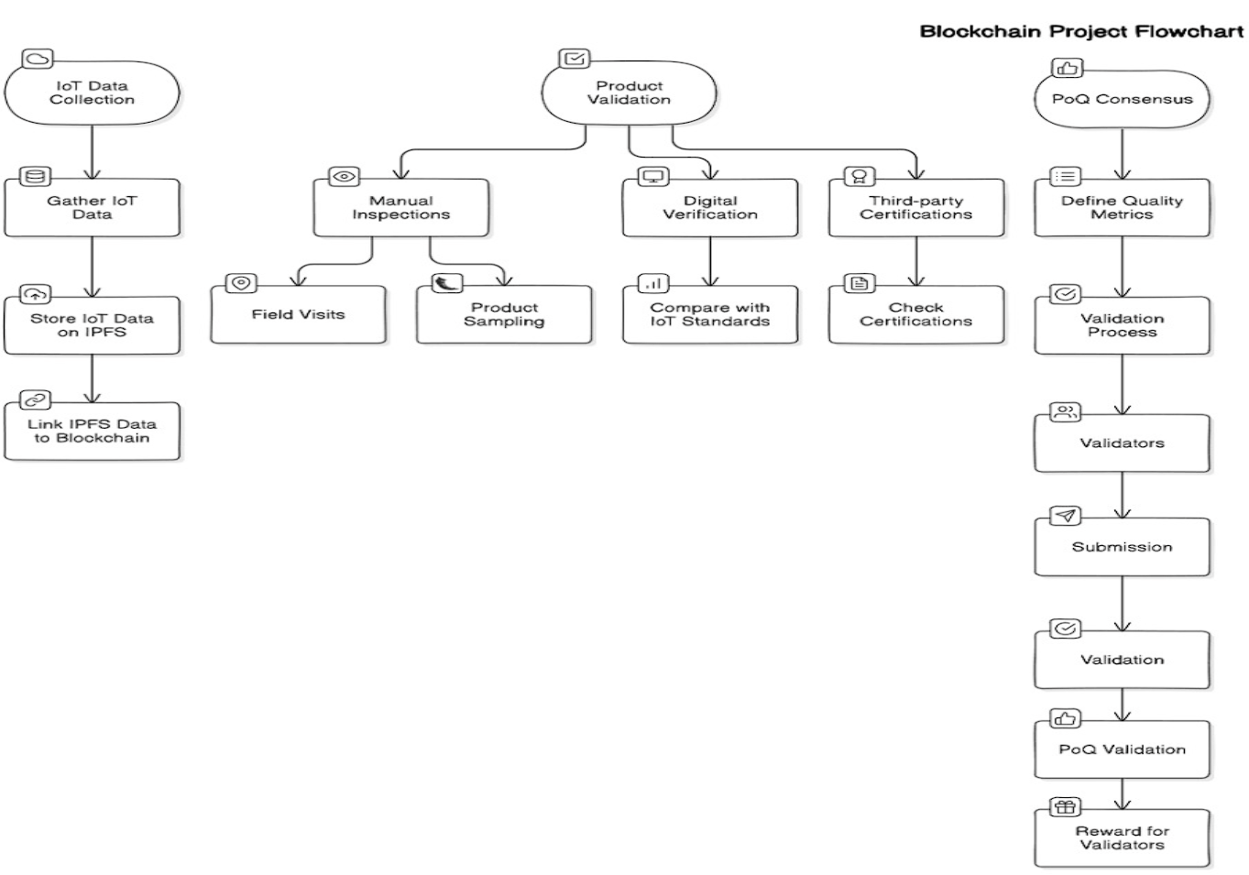

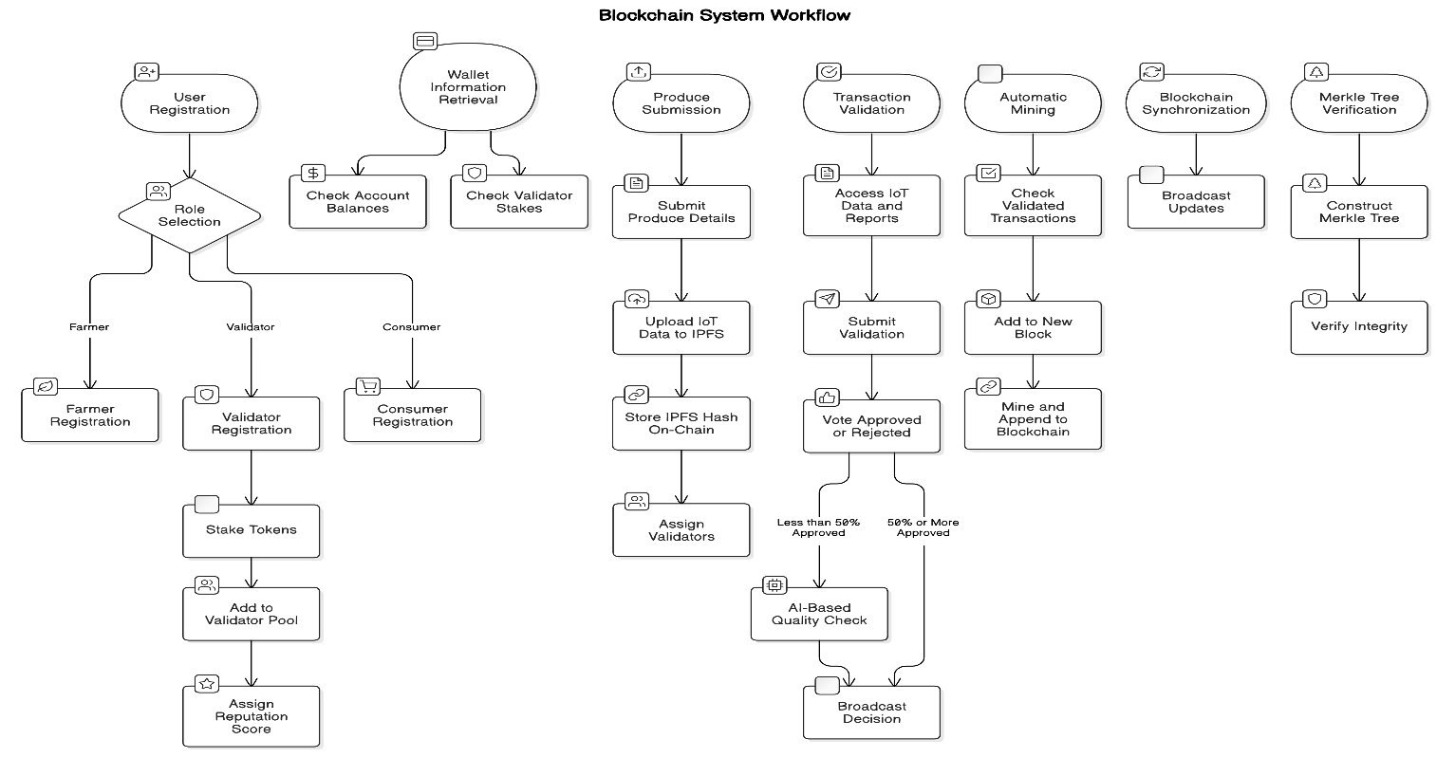

**V.CONCLUSION**

The integration of blockchain technology into the agricultural supply chain presents a transformative approach to addressing long-standing inefficiencies such as lack of transparency, price manipulation by intermediaries, and unreliable quality verification methods. This research proposes a custom blockchain-based solution that leverages Proof of Quality (PoQ) consensus mechanism, IoT-based quality monitoring, and smart contracts to create a trustworthy, decentralized, and efficient marketplace for farmers, consumers, and retailers. By eliminating intermediaries and enabling direct farmer-to-consumer transactions, the system ensures fair pricing, enhanced traceability, and improved financial inclusion for smallholder farmers.

The implementation of PoQ incentivizes high-quality agricultural production by rewarding farmers based on objective quality metrics, which are validated through IoT sensor data and manual inspections. The integration of QR code verification allows consumers to access detailed product histories, ensuring trust and confidence in the supply chain. Additionally, off-chain IPFS storage efficiently manages large IoT datasets while maintaining data integrity and security.

##### **VI.References**

[1] Agriculture Supply Chain Management Based on Blockchain Architecture and Smart Contracts- Adil El Mane; Volume 2022, Article ID 8011525, <https://onlinelibrary.wiley.com/doi/epdf/10.1155/2022/8011525>

[2] AGRICULTURE ON THE BLOCKCHAIN Sustainable Solutions for Food, Farmers, and Financing Henry Kim and Marek Laskowski York University December 2017

[3]Applying Blockchain in Agriculture: A Study on Blockchain Technology, Benefits, and Challenges

January 2021;DOI: [10.1007/978-3-030-60265-9_11](http://dx.doi.org/10.1007/978-3-030-60265-9_11)

Sandeep Kumar M,Maheshwari Venkat

[4], Blockchain Technology for Agriculture: Applications and Rationale; Hang Xiong1*Tobias Dalhaus2Puqing Wang3Jiajin Huang4,5

[5], Blockchain and agricultural supply chains traceability: research trends and future challenges**;** panelGiovanni Mirabelli a, Vittorio Solina-2020

[6] Exploring the role of blockchain technology in modern high-value food supply chains: global trends and future research directions; Giulia Chiaraluce, Deborah BentivogJj@**-**2019

[7] S. Viriyasitavat, and A. Hoonsopon, “Blockchain in the Supply Chain Management: A Review and Research Framework,” Logistics, vol. 3, no. 1, pp. 1-20, 2019.

[8]4] H. Lin, and N. Zhu, “Exploring the Potential of Blockchain

in Agriculture: A Literature Review,” Journal of Agricultural

Studies, vol. 6, no. 2, pp. 48-60, 2018.